 | 12 ATAR Physics  Modern Physics  Test 2017 (5%)  Student name:

1. A spacecraft moving at 95% of the speed of light passes the Earth on a journey to the star Lalande-21185 a distance of 8.29 light years.

In the frame of reference of the spacecraft (experienced by the crew) what time and spatial measurements of the journey are different compared to those measured by an Earth based observer? Which TWO statements are correct? [2 marks]

- Length contraction states, ‘the path length through space is longer than 8.29 light years’.
- Length contraction states, ‘the path length through space is shorter than 8.29 light years’.
- Time dilation states, ‘the clock on earth is moving slower’.
- Time dilation states, ‘the clock on the spacecraft is moving slower’.

In the frame of reference of the Earth what time and spatial measurements of the journey are different compared to those measured by an observer on the spacecraft? Which TWO statements are correct? [2 marks]

- Length contraction states, ‘the path length through space is shorter than 8.29 light years’.
- Length contraction states, ‘the path length through space will be 8.29 light years’.
- Time dilation states, ‘the clock on earth is moving slower’.
- Time dilation states, ‘the clock on the spacecraft is moving slower’.

2. Explain what is meant by the term, ‘inertial reference frame’. [1 mark]

3. Explain what is meant by the term, ‘luminiferous aether’ and what experiment lead to its demise? [2 marks]

4. State the two postulates of Special Relativity that Einstein used to reject the necessity for the luminiferous aether. [2 marks]

5. A student is on a spaceship traveling at 0.5c away from a star, at what speed would the starlight pass the student? Explain your answer. [3 marks]

6. The proposed new Sydney to Perth bullet train that travels at a speed of 0.482c. A passenger on the bullet train drops a shiny stainless-steel ball bearing from a height of 1.36m.

- What would be the time measured by the passenger for the ball bearing to fall to the floor? [2 marks]

- As the train passes through a level crossing, a stationary observer notices the ball bearing fall to the floor of the train. What would be the time measured by the stationary observer for the ball bearing to fall to the floor? [5 marks]

7. One of the biggest accelerators in the world is at CERN in Geneva, the site of the Large Electron-Positron (LEP) collider. It is 27 km long and accelerates the electrons (and positrons) to enormous energies in the 50 GeV in energy range. | 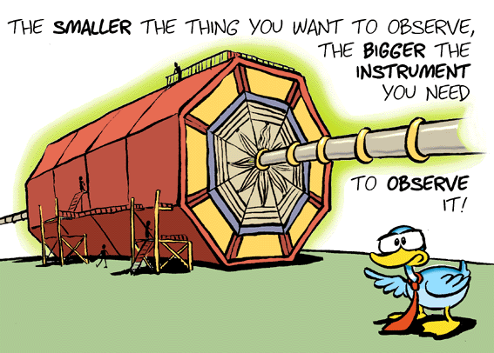

- Calculate the ‘rest-mass’ energy of a positron. Give your answer in MeV. [2 marks]

- Calculate the relativistic mass of an electron traveling along the particle accelerator with a speed of 0.99c [4 marks]

- What is the relativistic energy of an electron traveling along the particle accelerator with a speed of 0.99c? [4 marks]

8. The Hubble space telescope (HST), was the first space based telescope used for serious scientific research. The HST can collect data using both the IR and microwave regions of the EM spectrum. Explain why it is necessary to place such a telescope into space. [5 marks] | 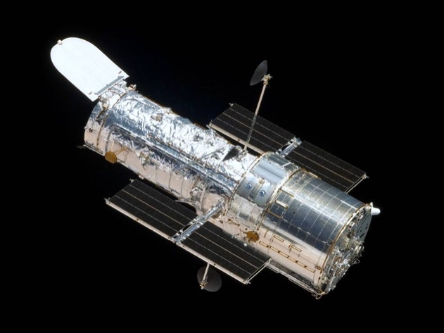

9. One of the most intense sources known to radio astronomers is the Galaxy NGC5128. Long exposure photographs show it to be a giant elliptical galaxy crossed by a band of dark. It lies about 1.50x10⁷ lightyears away from earth. Using a value of the Hubble constant of 73 kms⁻¹Mpc⁻¹, calculate the recessional velocity of NGC5128. [4 marks]

10. The K-line of light from singly ionised calcium has a wavelength of 393.3nm when measured in a laboratory. The same line in the spectrum of galaxy NGC 4889 has a wavelength of 401.8nm. Calculate the recessional velocity of NGC4889. [4 marks]

11. Consider the Feynman diagrams shown below. Identify the fundamental force begin described in each diagram. Write your answer in the space provided below the diagram. [4 marks]

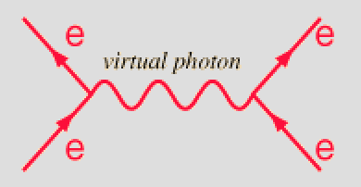 | 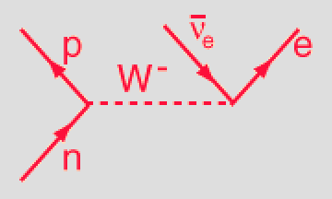
a) | b)
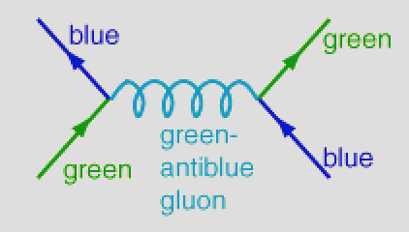 | 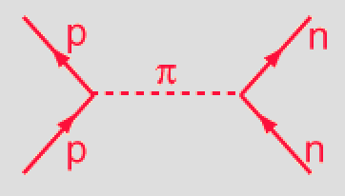
c) | d)

12. Determine which of the following reactions are forbidden. Explain your answer.

- p⁺ + p⁻ μ⁺ + e⁻ [2 marks]

- p⁺ + p⁺ p⁺ + π⁺ [2 marks]

- π⁻ + p⁺ p⁺ + π⁺ [2 marks]

